Library Management System
Overview
The Library Management System is a simple, console-based Python application designed to manage library book records efficiently. It allows users to add new books, view available books, search for books using Book ID, and store library data permanently using file handling.

Problem Addressed
Manual management of library records can lead to missing books, data inconsistency, difficulty in searching records, and lack of proper storage. This project provides a basic digital solution to organize and manage library book information effectively.

Main Features
Add Book – Adds new book records with book details
View Books – Displays all available books in the library
Search Book by Book ID – Finds a specific book using its unique ID
Menu-driven Interface – User-friendly menu for easy navigation
Input Validation – Handles incorrect inputs safely
Data Persistence – Stores library data in a file for future use

Python Concepts Used
Data Structures
Dictionary – Used to store library data with keys representing book attributes
Lists – Used as values inside the dictionary to hold multiple book records
Dictionary of Lists Structure – Each index position represents one book across all fields

This structure helps in efficient storage, searching, and updating of book records.

Control Flow
While Loop – Repeatedly displays the menu until the user exits
If / Elif / Else Statements – Used for menu selection and decision-making
For Loop – Used to iterate through book records for viewing and searching
Functions
show_menu() – Displays the main menu
add_book() – Adds a new book to the library
view_books() – Displays all book records
search_book() – Searches for a book using Book ID
save_to_file() – Saves library data to a file
exit_program() – Exits the program safely

Methods
List Methods
append() – Adds new book records
len() – Finds the number of books

Dictionary Methods
keys() – Accesses dictionary keys
values() – Accesses dictionary values
get() – Safely retrieves dictionary values

String Methods
strip() – Removes extra spaces from user input

Exception Handling
try / except Block – Handles invalid user input
ValueError Handling – Prevents program crash due to wrong data type
User-friendly Error Messages – Displays clear messages for incorrect input
Smooth Execution – Program continues running even after errors

File Handling and Libraries
File Handling – Library data is saved using file handling
CSV File Storage – Data is stored in a CSV file
Data Persistence – Ensures records remain available after program ends
Libraries Used – Pandas library is used for data handling

How to Run
Open Jupyter Notebook or Python environment
Open the Library Management System file
Run all cells or execute the program
Follow the menu instructions displayed

Input and Usage Guidelines
Numeric Inputs – Book ID and number of copies must be numbers
Text Inputs – Book Title and Author should be entered as text
Menu Selection – Choose options using numbers only
Invalid Input Handling – Error messages are shown for incorrect input
Exit Procedure – Select exit option to close the program safely

File and Dataset Details
Data File Name – Library data is stored in library.csv
File Location – Stored in the same folder as the program
Stored Fields – Book ID, Title, Author, Copies
File Creation – File is created automatically if it does not exist
Data Loading – Data can be reused when needed

Screenshots:
Dataframe
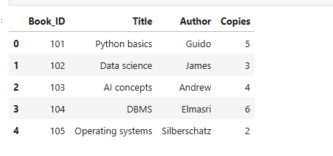

To add book

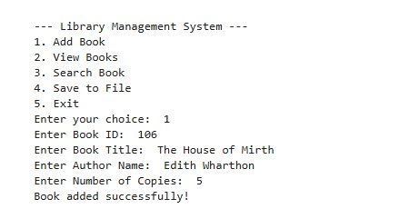

Viewing all books
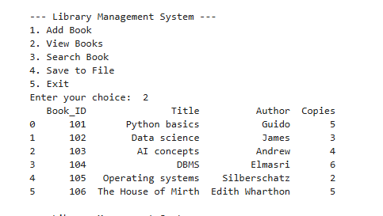
Search a book
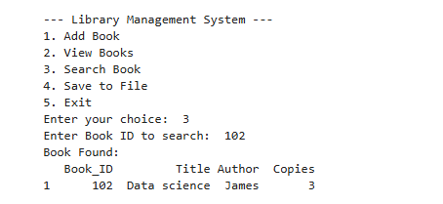

Save to file
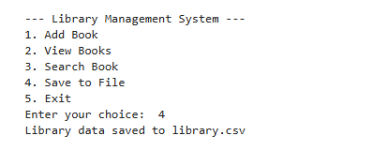

Save
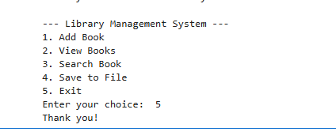

Assignment Fit and Extras
Meets all Python mini-project requirements
Real-world application related to library management
Proper use of functions, loops, and conditionals
Exception handling implemented
File handling for data storage
Easy to extend with additional features

Name: Divya Darshini M
Course: MBA
Subject: AI and ML for financial services
Project: Library Management System( using python)
Domain: Library / Education Management

